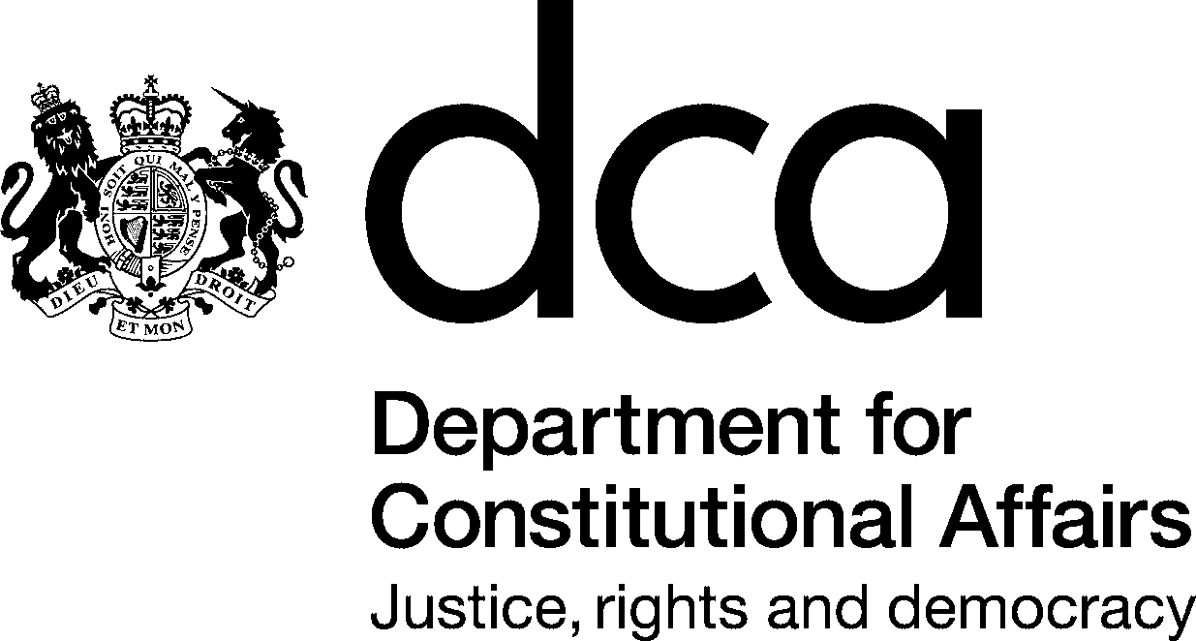  f | Selborne House  54 Victoria Street  London SW1E 6QW  T 020 7210 2600  F 020 7210 8550  E @dca.gsi.gov.uk  www.dca.gov.uk
Peter Robson
Computacenter (UK) Ltd
Hatfield Business Park
Hatfield Avenue
Hatfield, Herts
AL10 9TW
 | 10 September 2004
Dear Peter

Provision of a Statute Law Database Enquiry System

I am pleased to inform you that your tender dated 19th August 2004, as clarified and amended by correspondence set out below, has been accepted by the Department.

The Contract comprises the following documents:

- The Specification;

- the G-CAT Terms and Conditions;
- the Department’s correspondence date 20th, 23rd and 25th of August 2004;
- your company’s (including The Stationery Office, on your behalf) correspondence dated 23rd and 25th August and 3rd September 2004; and
5. this letter of acceptance.
The Project Manager will be Clare Allison (0207 210 2667). A contract start up meeting will be arranged for sometime in week commencing 13th September 2004.
We look froward to working with you and the TSO team.

Yours sincerely

Tony Hopkins
Head of the Statutory Publications Office

