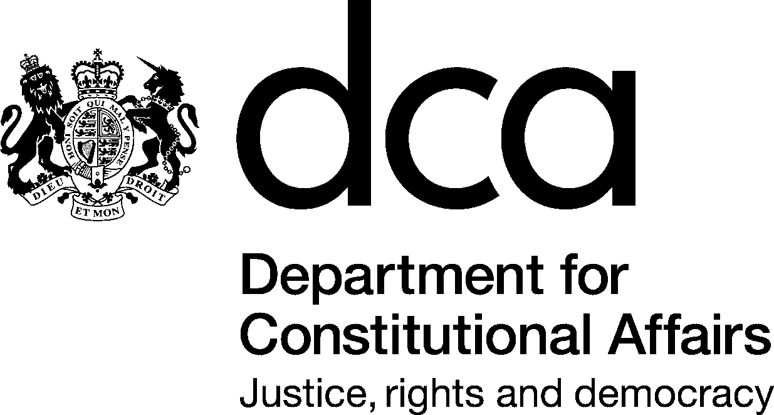  f | 5th Floor  30 Millbank  London SW1P 4XB  T 020 7217 4886  F 020 7217 2307  E mosun.hassanasst@dca.gsi.gov.uk  www.dca.gov.uk
Mr Francis Irving
<address removed>
7 February 2006
Dear Mr Irving

Re: Your Internal Review The internal review for your request for information about the Statute Law Database (SLD) has been completed.

The information in this case has been reconsidered to see whether the original decision not to disclose the information was correct. Your request was refused on the grounds of cost. I am satisfied that the cost of locating, retrieving and extracting the information to comply with your main request (for "a complete data base dump in machine-readable format") would exceed the ‘appropriate limit’ of £600. Under section 12 of the Freedom of Information Act public authorities are not required to comply with requests where doing so would exceed the appropriate limit. I therefore conclude that the original decision on your main request was correct.

I note that you ask for an alternative request to be considered in the event that "it becomes clear that (1) can not be answered in full". This is for: "a dump of the data from the "Documents" database as, described in Annex D2 of the document "Specification for the Provision of a Statute Law Database System" (made by Statutory Publications Office, when the DCA was the Lord Chancellors Department, author KP, no document identifier)………I would like the latest version of this database dump."

Having considered the material in relation to the alternative request, I am not satisfied that the cost of providing the information would exceed the appropriate limit. However, I am satisfied that the exemptions under Sections 22(1) and 43(2) apply (as they would also have applied to your main request had the exemption on grounds of cost not applied). Your alternative request is, therefore, also refused under those sections of the Act.

a) s. 22(1) (Information intended for Future publication)

The content of SLD constitutes information held by the Department with view to its publication at a future date and would therefore be refused under section 22(1) of the Act.

SLD is still under development. It is planned that the database will be piloted for public access from April 2006 with a view to release to the general public later in the year. It would not be in the public interest to make the content of the database available in advance of the planned publication date for this reason:

It is in the public interest that the content of the database should be published as part of a properly planned and managed activity. There is also a strong public interest in ensuring before publication that the database is adequately piloted for usability and that the information contained in it meets stringent quality criteria, particularly in relation to completeness and accuracy.

The Department is committed to providing equal access to the revised Statute book for the whole of the UK population as soon as is reasonably practical in pursuance of the Department’s responsibility to ensure that citizens may have access to the laws by which they are bound.

b) s. 43(2) (Commercial Interests)

Notwithstanding the planned online publication of SLD, the underlying data constitutes information the disclosure of which would, or would be likely to, prejudice the commercial interests of the Department and would therefore be refused under section 43(2) of the Act.

The electronic data upon which the editorial content of the database is based constitutes commercially valuable information. The Statutory Publications Office is required to develop a commercial strategy in line with the government’s Wider Markets Initiative. The principal document relating to this initiative is ‘Selling into Wider Markets: A Policy Note for Public Bodies’ published by HM Treasury in December 2002. This document may be accessed on the HM Treasury website.

The commercial strategy has yet to be finalised and the precise scope of it can not, therefore, be given. It is, however, envisaged that commercial contracts will be entered into with private organisations for the supply of the data, or extracts of the data, for re-use in their applications. Examples of such applications might be commercial databases of statute law or specialist legal publications such as practitioners’ guides to particular areas of statute law. It is likely, in pursuance of the commercial strategy, that a private sector partner will be found to assist the Department in exploiting the commercial value of the data.

It is in the public interest that the Department should seek to maximise the return to the public purse for the considerable investment that has been put into the development of SLD over a number of years. It is intended that overall charges will not exceed the total cost of collection, production, reproduction and dissemination of the data (including the development costs of the database) together with a reasonable return on investment.

Finally, I have also looked at the procedural aspects of DCA’s handling of your request and I confirm that I am satisfied that the Department complied with its obligations under the Act in responding in a full and timely manner.

If you are not content with the outcome of the internal review, you have the right to apply directly to the Information Commissioner for a decision. The Information Commissioner can be contacted at:

Information Commissioner's Office
Wycliffe House
Water Lane
Wilmslow
Cheshire
SK9 5AF

If you have any further queries please do not hesitate to contact me.

Yours sincerely,

Michael Yates

Access Rights Unit

